Project Name : Authentication_Module
Company Name : Marolix Technologies
Group Members : Shanmukha,
Venkat sai Kumar,
Vamsi Krishna,
Ravi mishra,
Siva Shankhar
Requirements : Python 3.8 standard version,
Django 4.2.7,
Rest Frame Work,
PostgresQL latest version,
Postman latest version

Documentation
step -1 :
Creating project folder and virtual environment
we need to create a new folder and name it later on we have to open that folder that folder on vs code and next we have to click on terminal,select new terminal and then we have to use the following commands:
*python -- version
we have to check the version of python
*pip -- version
we have to check pip version
By using the below commands we have to activate virtual environment
*pip install virtualenv
*python -m virtualenv venv
*.\venv\Scripts\activate
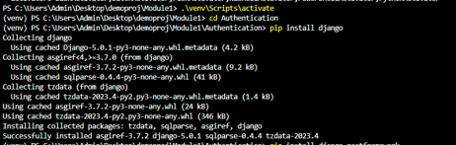
By using this command virtual environment is created successfully.
In this python project we have to run the django server for that we are using django command
*pip install django
*pip install pyscopg2 # to connect with database
*django-admin startproject firstproject
*cd -\firstproject\
*python manage.py startapp firstapp
we have to install django rest framework so we are using the below command
*pip install djangorestframework
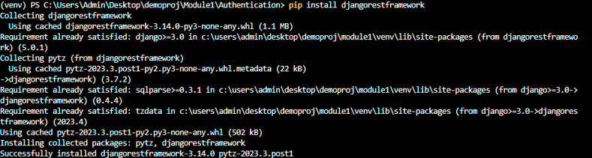

After that go setting.py file and replace DATABASE with below code
DATABASES = {
'default': {
'ENGINE': 'django.db.backends.postgresql',
'NAME': 'Module_db',
'USER': 'postgres',
'PASSWORD': '123',
'HOST': 'localhost',
'PORT': '5432'
}
}

*python manage.py migrate
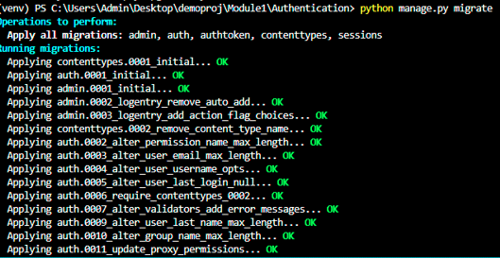

*Go to urls.py in project folder and add include with below code
path('',include('AuthApp.urls')),

*And create one more urls.py in our Application and then write below code
from .import views

urlpatterns = [
path('',views.input),
path('login/',views.login,name='login'),
path('reset/',views.reset,name='reset'),
path('change-password/', views.change_password, name='change_password'),
path('visitors/',views.visitors,name='visitors'),
path('logout/',views.logout,name='logout'),
]

- And then create one more seriailizers file in your Application folder and add below code
from rest_framework import serializers
from django.contrib.auth.models import User
from .models import User_data

class userseralizer(serializers.ModelSerializer):
class Meta:
model=User
fields=['id','username','password','email']

class user_data_seralizer(serializers.ModelSerializer):
class Meta:
model=User_data
fields='__all__'

Step-2:
Creating the user
We need to import module User from Django package by using
- from django.contrib.auth.models import User
And then pass the attributes in that class by using syntax
- user_details=User.objects.create_user(username= user_username , password=user_password, email=user_email)
- user_details.save() # To save that user

Here ,
(user_username, user_password , user_email) =input data which Is taken from user

NOTE:
By using saving the user using User Module, it will save the relevant data in database along with the encrypted password , which enhance security for password

And we can get tokens by using this Token inbuilt method
By using this syntax
- token=Token.objects.create(user=user_details)

def input(request):
if request.method=='POST':
username=request.data['username']
password=request.data['password']
email=request.data['email']
try:
user_details=User.objects.create_user(username=username,password=password,email=email) #Saving the user
user_details.save()
token=Token.objects.create(user=user_details)
serilizer1=user_data_seralizer(data=request.data)
if serilizer1.is_valid():
serilizer1.save()
except:
return Response({"Message" : "username already exsists try again "}) # if username already exsists
serilizer=userseralizer(user_details) #converting the user details using serilizer
return Response({'token':token.key, "user": serilizer.data}) #returning the data

Login APi:
When user needs to login , user needs to provide username and password
Basically in Django password is encrypted while saving the username and password , to verify that encrypted password we need to use inbuilt method authenticate method which is available in Django inbuilt package
By using this syntax
- from django.contrib.auth import authenticate
If username and password is not valid , then it will return None
And we can get tokens by using this Token inbuilt method orelse if token is not there then it will generate new token
By using this syntax
- token,value=Token.objects.get_or_create(user=user_details)

def login(request):
if request.method=="POST":
username=request.data['username']
password=request.data['password']
user_details=authenticate(username=username,password=password) #if user is not valid it will return None
if user_details is not None:
user_details=User.objects.get(username=username)
token,value=Token.objects.get_or_create(user=user_details)
serializer=userseralizer(user_details)
user_data=User_data.objects.get(username=username)
serializer1=user_data_seralizer(user_data)
count=serializer1.data['count']
count=int(count)+1
User_data.objects.filter(username=username).update(count=count)
return Response({'message': 'Valid user','token':token.key,'user':serializer.data})
return Response({'message':'Invalid User'})

Reset Api:
To Update password in django we will be having an inbulit method i.e “set_password”
By using synatx :
- user=User.objects.get(username=username)
- user.set_password(new_password) #set_password is inbulit method which will encrpt newpassword
- user.save()

def reset(request):
if request.method == "PUT":
username = request.data.get('username')
new_password = request.data.get('password')
email = request.data.get('email')
if not all([username, new_password, email]):
return Response({'message': "All fields are required."}, status=status.HTTP_400_BAD_REQUEST)
try:
user_details = User.objects.get(username=username)
serializer = userseralizer(user_details)
if email == serializer.data['email']:
#user, created = User.objects.update_or_create(username=username, email=email,defaults={'password': new_password}) # this method will automatically replace and save paticular feild , but it won't encript password
user=User.objects.get(username=username)
user.set_password(new_password) #set_password is inbulit method which will encrpt new password
user.save() #it will save encrypted password
return Response({'message': "User updated"})
else:
return Response({'message': "Email does not match."}, status=status.HTTP_400_BAD_REQUEST)
except User.DoesNotExist:
return Response({'message': "User not found."}, status=status.HTTP_404_NOT_FOUND)
return Response(status=status.HTTP_200_OK)

Change_password Api :
Add this below code in Change_password api
def change_password(request):
if request.method == "PUT":
current_password = request.data['current_password']
new_password = request.data['new_password']
username = request.data['username']
if not all([current_password, new_password,username]):
return Response({'message': "Both current and new passwords are required."}, status=status.HTTP_400_BAD_REQUEST)
try:
user_details = User.objects.get(username=username)
if check_password(current_password,user_details.password):
#user, created = User.objects.update_or_create(username=username, defaults={'password': new_password}) # this method will automatically replace and save paticular feild , but it won't encript password
user=User.objects.get(username=username)
user.set_password(new_password) #set_password is inbulit method which will encrpt new password
user.save() #it will save encrypted password
return Response({'message': "Password changed successfully"})
return Response({"message": "current password is incorrect"})
except:
return Response({'message': "User with that details not found."}, status=status.HTTP_400_BAD_REQUEST)
return Response(status=status.HTTP_200_OK)

Logout Api:
We just need to delete the Token ,so that user can able to do that logout
def logout(request):
request.user.auth_token.delete()
return Response({"Note" : "Authorization was Succesful and token deleted ",
"message": "logout was successful"})

Visitors Api:
def visitors(request):
visitors_count=0
data=User_data.objects.all()
serilizer=user_data_seralizer(data,many=True)
for value in serilizer.data:
visitors_count+=value['count']
return Response({"Visitors count":visitors_count})

